REVIEW EXERCISE #5A

1. | According to 5;2.2.1, how must package markings be applied?
2. | According to 5; 2.2.2, all marking required by 2.1 …
a)
b)
c)
d)
e)
3. | In general, what markings are required for all packages of dangerous goods?
4. | What are the languages to be used for package markings?

5. | For the following shipment, draw all applicable markings on the package below.
 | - 20 L Paraldehyde, passenger aircraft, 1 x UN 4G combination package.

6. | For the following shipment, is the package below marked correctly? If not, why not?
 | - 1 L 1-Pentene, passenger aircraft, 1 x UN 4D combination package.

UN1108 1-Pentene

Shipper: Consignee: Name Name
Address Address

u 4D/X 10/S/11
n XX/ABC123

8. | For the following shipment, is the package below marked correctly? If not, why not?
 | - 60 L Sodium methylate solution, PG III, cargo aircraft, 1 x UN 1A1 single package.

Shipper: Consignee:
Name Name
Address Address

ID1289
Sodium methylate solution

_{u} 1A1/Z 1.5/S/11
^{n} XX/ABC123

REVIEW EXERCISE #5B

1. | According to 5;3.1, what are the main requirements to label?

2. | According to 5;3.2.8, how must labels be applied?
3. | What is the shape of a Hazard label and a Handling label?
 | Hazard:
 | Handling:

4. | For the following shipment, draw all applicable markings AND labels on the package
 | below.
 | - 25 L Silicon tretrachloride, 1 x UN 1A1 single package.

5. | For the following shipment, is the package below marked correctly? If not, why not?
 | - 15 kg Sodium, 1 x UN 1H2 single package.
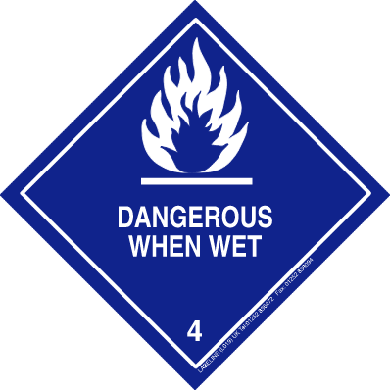

_{u} 1H2/Z 1.5/160/11
^{n} XX/ABC123

UN1428 Sodium

Shipper: Consignee:
Name Name
Address Address

6. | For the following shipment, is the package below marked correctly? If not, why not?
 | - 5 L Sodium methylate solution, PG III, passenger aircraft, 1 x UN 1A1 single package.

Sodium methylate UN1289

Shipper: Consignee:
Name Name
Address Address

_{u} 1A1/X 1.5/160/11
^{n} XX/ABC123

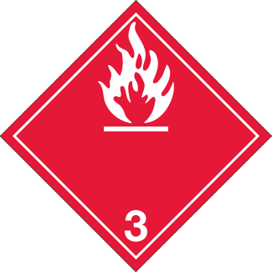

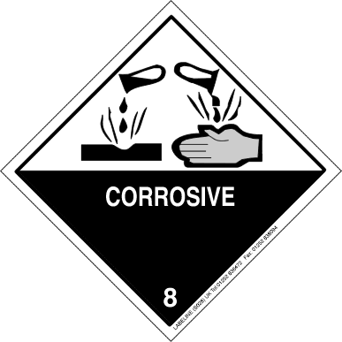

REVIEW EXERCISE #5C

1. | Although not an ICAO requirement, what is the industry standard dangerous goods transport document?
2. | Who must complete the dangerous goods transport document?
3. | In addition to the languages, which may be required by the State of Origin, what other language should be used for the dangerous goods transport document?
4. | In addition to the dangerous goods transport document, what other document accompanies an air cargo shipment?
5. | For how long must a shipper retain the dangerous goods transport document?
6. | What is the correct sequence of the dangerous goods description?
7. | What is the correct sequence of the quantity of dangerous goods, number and type of packagings?

8. | For the following shipment, complete the portion of Shipper’s Declaration below.
 | - 25 L Sulphur chlorides, UN 4G combination packages.

NATURE AND QUANTITY OF DANGEROUS GOODS
Dangerous Goods Identification
UN or ID No. | Proper Shipping Name | Class or Division (Subsidiary risk) | Packing Group | Quantity and type of packaging | Packing Inst. | Authorization

9. | For the following shipment, is the portion of Shipper’s Declaration below completed correctly? If not, why not?
 | - 25 kg Thallium chlorate, passenger aircraft, UN 4C2 combination packages.

NATURE AND QUANTITY OF DANGEROUS GOODS
Dangerous Goods Identification
UN or ID No. | Proper Shipping Name | Class or Division (Subsidiary risk) | Packing Group | Quantity and type of packaging | Packing Inst. | Authorization
UN2573 | Thallium chlorate | 6.1 (5.1) | II | 5 Natural wood boxes x 25 kg | 562 | -

10. | For the following shipment, is the portion of Cargo Air Waybill and the Shipper’s Declaration below completed correctly? If not, why not?
 | - 10 L Triethylamine, passenger aircraft, 4F combination packages.
 | AWB:
 | DGD:

Airport of Departure
Montreal
To  CDG |  | By first carrier  Air France |  |  | To |  | By | To |  | By
Airport of Destination
Paris, Charles de Gaulle
Handling Information
Dangerous goods as per attached documentation. |  |  |  |  |  |  |  |  |  |  |  |  |  | SCI
Number of Pieces | Gross Weight |  | kg  lb | Rate Class |  | Chargeable Weight |  |  | Rate / Charge |  | Total |  | Nature and Quantity of Goods
10 | 15 |  | K |  |  |  |  |  |  |  |  |  | Liquid chemicals (Triethylamine, UN1296)

 | Shipper  Quebec Chemicals Ltd.  12345 Cote de Liesse  Dorval, Canada |  |  |  |  |  | Air Waybill No. 057 - 1111 2222  Page 1____ of 1___ Pages  Shipper’s Reference Number __________________
 | Consignee  FRG Chemicals Ltd.  10 Rue Blanche  Paris, France |  |  |  |  |  | 
 | Two completed and signed copies of this Declaration must be handed to the operator. |  |  |  |  |  | WARNING: Failure to comply in all respects with the applicable Dangerous Goods Regulations may be in breach of the applicable law, subject to legal penalties.
 | TRANSPORTATION DETAILS |  |  |  |  |  | This Declaration must not, in any circumstances, be
 | This shipment is within the limitations prescribed for: (delete non-applicable)  PASSENGER CARGO  AND CARGO AIRCRAFT  AIRCRAFT ONLY |  | Airport of Departure:  Montreal |  |  |  | completed and/or signed by a consolidator, a forwarder or an IATA Cargo Agent.
 | Airport of Destination:  Paris, Charles de Gaulle |  |  |  |  |  | Shipment type (delete non-applicable):  NON-RADIOACTIVE RADIOACTIVE
NATURE AND QUANTITY OF DANGEROUS GOODS

Dangerous Goods Identification

UN or  ID No. |  | Proper Shipping Name |  | Class or  Division  (Subsidiary  Risk) |  | Packing  Group |  | Quantity and  type of Packing | Packing  Inst. |  | Author-  ization
UN  1269 |  | Triethylamine |  | 3 (8) |  | II |  | 10 Reconstituted wood boxes (4F) x 1 L | 363 |  | -
Additional Handling Information:

 | I hereby declare that the contents of this consignment are fully and accurately described above by the proper shipping name and are classified, packaged, marked and labelled, and are in all respects in the proper condition for transport by air according to the applicable International and National Government Regulations. I declare that all of the applicable air transport requirements have been met. |  |  |  | Name/Title of Signatory: Tom Jones, Manager  Place and Date: Montreal, October 1, 2011  Signature: Tom Jones

ALL PACKED IN ONES vs. OVERPACKS

There are 2 “special” ways a Shipper can package their shipments: All Packed In Ones and Overpacks. These 2 different ways of packaging are used by Shippers to save costs, and for ease of handling.

Shipment Example

A Shipper needs to send 3 chemicals to one of their clients:

- 2.0 L Fluoroanilines, UN2941
    - Metal Can Inner Package
    - 4G Outer Package

- 0.5 L Fluorobenzene, UN 2387
    - Plastic Inner Package
    - 4G Outer Package

- 0.5 L Fluoroboric acid, UN 1775
    - Glass Inner Package
    - 4G Outer Package

The Shipper has 3 options of how to package this shipment:

1. Each item individually packaged (Inner Package and Outer Packages) according to the Blue Pages and Packing Instructions.
This option has already been dealt with in class.

2. Each item individually packaged in their respective INNER PACKAGES, according to the Packing Instructions, THEN COMBINED together with other Inner Packages into an Outer Package (ALL PACKED IN ONE) for protection and ease of handling.

3. Each item individually packaged (Inner Package and Outer Packages) according to the Blue Pages and Packing Instructions, THEN COMBINED together with other complete Outer Packages into ANOTHER Outer Package (OVERPACK) for ease of handling.

All Packed In Ones

An All Packed In One is a large package that contains smaller, inner packages ONLY of different Dangerous Goods.

The Shipper has the 3 chemicals that have only been packed in their Inner Packages.

However, because they are going to the same Consignee, she puts her Inner Packages into one outer package (All Packed In One). Since the All Packed In One is the outer package, it DOES affect the integrity of the shipment, and therefore, it must comply with the applicable Packing Instructions.
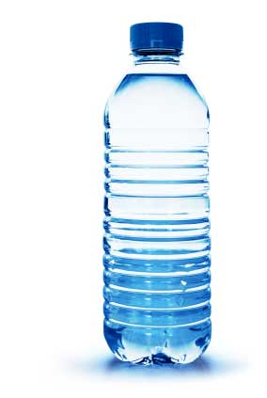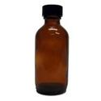

Inner Packages
containing liquids
or solids.

All Packed In One
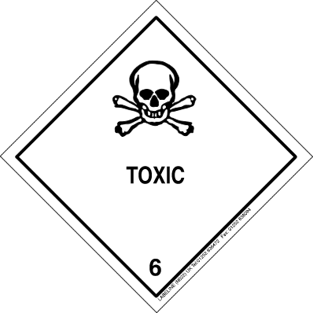
containing the
Inner Packages.

There are a number of rules that apply to All Packed In Ones. They are shown over the next 2 pages.

Example

To make it more understandable, let’s work through our shipment.

The Shipper wants to ship the 3 chemicals together in an All Packed In One, on a Passenger Aircraft.

The first step is to get the information for the 3 items.

 | Fluoroanilines  UN2941 | Fluorobenzene  UN 2387 | Fluoroboric acid  UN 1775
Net quantity shipped | 2.0 L | 0.5 L | 0.5 L
Class or Division | 6.1 | 3 | 8
Packing Group | III | II | II
Packing Instruction | 655 | 353 | 851
Max net quantity per inner package (Glass) | 2.5 L | 5.0 L | 1.0 L
Max net quantity per outer package (4G) | 60.0 L | 5.0 L | 1.0 L

The second step is to determine whether this shipment is allowable as an All Packed In One. Answer the following questions to make that determination.

 |  | YES or NO
1. | Do the inner packagings comply with their Packing Instructions?  (Read 4;1.1.9 a)) | Yes
2. | Does the outer package comply with the Packing Instructions?  (Read 4;1.1.9 b)) | Yes
3. | Does the package meet the specification performance test for the most restrictive Packing Group? (Read 4;1.1.9 c)) | Yes
4. | Are the dangerous goods compatible?  (Read 4;1.1.9 d) and Table 7-1) | Yes
5. | Is the “Q-Value” less than or equal to 1.0?  (Read 4;1.1.9 e)) | Yes
Let’s now look at Question #5 in detail.

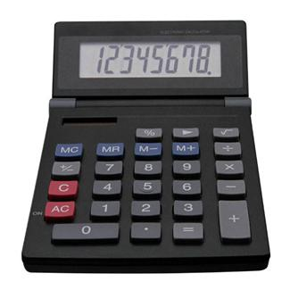

Calculate if the Q-Value less than or equal to 1.0?

Fluoroanilines: | Net quantity shipped | 2.0 L | = 0.0333
 | Max quantity per outer | 60.0 L
Fluorobenzene: | Net quantity shipped | 0.5 L | = 0.1
 | Max quantity per outer | 5.0 L
Fluoroboric acid: | Net quantity shipped | 0.5 L | = 0.5
 | Max quantity per outer | 1.0 L
 |  | Total | = 0.6333
 | Q-Value | = | 0.7 *

* Please note that the Q-Value is always rounded up to one decimal place.
(See 4.1.5.7.1 e)

Therefore, because …

- The inner packagings comply with their Packing Instructions;
- The outer packaging complies with the Packing Instructions;
- The packing meets the performance specification for the most restrictive Packing Group;
- The dangerous goods are compatible; and
- The Q-Value is less than or equal to 1.0

… this shipment is permitted as an All Packed In One.

Overpacks

An Overpack is a large package that contains smaller, complete packages of normally different Dangerous Goods.

The Shipper has those same 3 chemicals that have been properly, and completely packaged. As mentioned in Option #1, she could send the 3 packages individually, as they are, because they are individually packaged for transport.

However, because they are going to the same Consignee, instead of sending 3 separate packages to the airline, she puts her packages into another outer package (Overpack), making it easier to handle. The Overpack could be shrink-wrap, banding, netting, a box or a crate. The Overpack does not increase the integrity of the shipment, it only holds the packages together, and therefore does not need to comply with the applicable Packing Instructions.
Inner Packages
containing liquids
or solids.

Outer Packages
containing the
Inner Packages.
(Could be shipped
as 3 packages.)

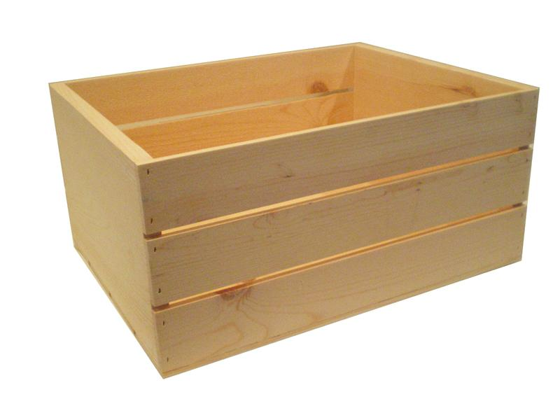

OVERPACK, used to
contain several complete
Outer Packages, for
ease of handling.

CASE STUDY #1

For the following shipment, is the Cargo Air Waybill (only portion shown) , the package and the Shipper’s Declaration below completed correctly? If not, why not? Provide your answers in the space below:

- 2 L UN1297, PG II, passenger aircraft.
AWB:
Package:
DGD:
AWB (portion shown)

Airport of Departure
London, Heathrow
To  AMS |  | By first carrier  KLM |  |  | To |  | By | To |  | By
Airport of Destination
Amsterdam, Schiphol
Handling Information
Dangerous goods as per associated Shipper’s Declaration. |  |  |  |  |  |  |  |  |  |  |  |  |  | SCI
Number of Pieces | Gross Weight |  | kg  lb | Rate Class |  | Chargeable Weight |  |  | Rate / Charge |  | Total |  | Nature and Quantity of Goods
2 | 5 |  | K |  |  |  |  |  |  |  |  |  | Chemicals

Package
Shipper’s declaration

_{u} 4B/Z 10/S/11
^{n} GB/ABC123
Shipper: Consignee:
Royal Chemicals Plc. Orange Manufacturing Ltd.
10 Water St. Beekstraat 120
London, UK Schiphol, Netherlands

Trimethylamine aqueous solution UN 1297
 | Shipper  Royal Chemicals Plc.  10 Water St.  London, UK |  |  |  |  |  | Air Waybill No. 074 – 2222 3333  Page ____ of ___ Pages  Shipper’s Reference Number __________________
Consignee
Orange Manufacturing Ltd.
Beekstraat 120
Schiphol, Netherlands

 | Two completed and signed copies of this Declaration must be handed to the operator. |  |  |  |  |  | WARNING: Failure to comply in all respects with the applicable Dangerous Goods Regulations may be in breach of the applicable law, subject to legal penalties.
 | TRANSPORTATION DETAILS |  |  |  |  |  | This Declaration must not, in any circumstances, be
 | This shipment is within the limitations prescribed for: (delete non-applicable)  PASSENGER CARGO  AND CARGO AIRCRAFT  AIRCRAFT ONLY |  | Airport of Departure:  London |  |  |  | completed and/or signed by a consolidator, a forwarder or an IATA Cargo Agent.
 | Airport of Destination:  Amsterdam |  |  |  |  |  | Shipment type (delete non-applicable):  NON-RADIOACTIVE RADIOACTIVE
NATURE AND QUANTITY OF DANGEROUS GOODS

Dangerous Goods Identification

UN or  ID No. |  | Proper Shipping Name |  | Class or  Division  (Subsidiary  Risk) |  | Packing  Group |  | Quantity and  type of Packing | Packing  Inst. |  | Author-  ization
UN  1297 |  | Trimethylamine aqueous solution |  | 8 (3) |  | II |  | 2 Aluminium boxes x 1 L | 352 |  | -
Additional Handling Information:

 | I hereby declare that the contents of this consignment are fully and accurately described above by the proper shipping name and are classified, packaged, marked and labelled, and are in all respects in the proper condition for transport by air according to the applicable International and National Government Regulations. I declare that all of the applicable air transport requirements have been met. |  |  |  | Name/Title of Signatory: James Smythe, Export Clerk  Place and Date: London, October 1, 2011  Signature: JSmythe

CASE STUDY #2

For the following shipment, is the portion of Cargo Air Waybill, the package and the Shipper’s Declaration below completed correctly? If not, why not?
- 30000 L Vanadium oxytrichloride.
AWB:
Package:
DGD:

Airport of Departure
Sydney
To  SEL |  | By first carrier  KE |  |  | To |  | By | To |  | By
Airport of Destination
Seoul
Handling Information
Dangerous goods as per attached Shipper’s Declaration. |  |  |  |  |  |  |  |  |  |  |  |  |  | SCI
Number of Pieces | Gross Weight |  | kg  lb | Rate Class |  | Chargeable Weight |  |  | Rate / Charge |  | Total |  | Nature and Quantity of Goods
1000 | 35000 |  | K |  |  |  |  |  |  |  |  |  | Chemicals

_{u} 1A1/X 1.4/S/11
^{n} AUS/MM123
Shipper: Consignee:
Foster Chemicals Plc. Seoul Manufacturing Ltd.
100 Ocean St. 210 Gwangjang Dong
Sydney, Australia Seoul, Republic of Korea

Vanadium oxychloride UN2443
 | Shipper  Foster Chemicals Plc.  100 Ocean St.  Sydney, Australia |  |  |  |  |  | Air Waybill No. 180 – 2211 3344  Page 1 of 1 Pages  Shipper’s Reference Number __________________
Consignee
Orange Manufacturing Ltd.
Beekstraat 120
Schiphol, Netherlands

 | Two completed and signed copies of this Declaration must be handed to the operator. |  |  |  |  |  | WARNING: Failure to comply in all respects with the applicable Dangerous Goods Regulations may be in breach of the applicable law, subject to legal penalties.
 | TRANSPORTATION DETAILS |  |  |  |  |  | This Declaration must not, in any circumstances, be
 | This shipment is within the limitations prescribed for: (delete non-applicable)  PASSENGER CARGO  AND CARGO AIRCRAFT  AIRCRAFT ONLY |  | Airport of Departure:  Seoul |  |  |  | completed and/or signed by a consolidator, a forwarder or an IATA Cargo Agent.
 | Airport of Destination:  Sydney |  |  |  |  |  | Shipment type (delete non-applicable):  NON-RADIOACTIVE RADIOACTIVE
NATURE AND QUANTITY OF DANGEROUS GOODS

Dangerous Goods Identification

UN or  ID No. |  | Proper Shipping Name |  | Class or  Division  (Subsidiary  Risk) |  | Packing  Group |  | Quantity and  type of Packing | Packing  Inst. |  | Author-  ization
UN  2443 |  | Vanadium oxytrichloride |  | 8 |  | II |  | 1000 Steel drums (1A1) x 3000 L | 855 |  | -
Additional Handling Information:

 | I hereby declare that the contents of this consignment are fully and accurately described above by the proper shipping name and are classified, packaged, marked and labelled, and are in all respects in the proper condition for transport by air according to the applicable International and National Government Regulations. I declare that all of the applicable air transport requirements have been met. |  |  |  | Name/Title of Signatory: Jane Honeywell, Supervisor  Place and Date: Sydney, October 1, 2011  Signature: Jane Honeywell

CASE STUDY #3

For the following shipment, is the portion of Cargo Air Waybill, the package and the Shipper’s Declaration below completed correctly? If not, why not?
- 60 L UN2589.
AWB:
Package:
DGD:

Airport of Departure
Dubai
To  YYZ |  | By first carrier  EK |  |  | To |  | By | To |  | By
Airport of Destination
Toronto
Handling Information
Dangerous goods. Please protect from freezing. |  |  |  |  |  |  |  |  |  |  |  |  |  | SCI
Number of Pieces | Gross Weight |  | kg  lb | Rate Class |  | Chargeable Weight |  |  | Rate / Charge |  | Total |  | Nature and Quantity of Goods
12 | 84 |  | K |  |  |  |  |  |  |  |  |  | Chemicals

Vinyl chloroacetate 2589

Shipper: Consignee:
UAE Chemicals LLC York Manufacturing Ltd.
1200 Dubai Bypass Rd. 1 Yonge St.
Dubai, UAE Toronto, Canada

u 4G/Y 10/S/10
n UAE/DB123

 | Shipper  UAE Chemicals LLC  1200 Dubai Bypass Rd.  Dubai, UAE |  |  |  |  |  | Air Waybill No. 176 – 0011 0022  Page 1 of 1 Pages  Shipper’s Reference Number __________________
Consignee
York Manufacturing Ltd.
1 Yonge St.
Toronto, Canada
 | Two completed and signed copies of this Declaration must be handed to the operator. |  |  |  |  |  | WARNING: Failure to comply in all respects with the applicable Dangerous Goods Regulations may be in breach of the applicable law, subject to legal penalties.
 | TRANSPORTATION DETAILS |  |  |  |  |  | This Declaration must not, in any circumstances, be
 | This shipment is within the limitations prescribed for: (delete non-applicable)  PASSENGER CARGO  AND CARGO AIRCRAFT  AIRCRAFT ONLY |  | Airport of Departure:  Dubai |  |  |  | completed and/or signed by a consolidator, a forwarder or an IATA Cargo Agent.
 | Airport of Destination:  Toronto |  |  |  |  |  | Shipment type (delete non-applicable):  NON-RADIOACTIVE RADIOACTIVE
NATURE AND QUANTITY OF DANGEROUS GOODS

Dangerous Goods Identification

UN or  ID No. |  | Proper Shipping Name |  | Class or  Division  (Subsidiary  Risk) |  | Packing  Group |  | Quantity and  type of Packing  12 AlSoori | Packing  Inst. |  | Author-  ization
UN  2589 |  | Vinyl chlorideacetate |  | 6 (3) |  | II |  | 10 Fibreboard boxes (4G) x 5 L | 662 |  | -
Additional Handling Information:

 | I hereby declare that the contents of this consignment are fully and accurately described above by the proper shipping name and are classified, packaged, marked and labelled, and are in all respects in the proper condition for transport by air according to the applicable International and National Government Regulations. I declare that all of the applicable air transport requirements have been met. |  |  |  | Name/Title of Signatory: Jamal Al Soori, Clerk  Place and Date: Dubai, October 1, 2011  Signature: AlSoori

CASE STUDY #4

For the following shipment, is the portion of Cargo Air Waybill, the package and the Shipper’s Declaration below completed correctly? If not, why not?
- 600 L Wood preservatives, liquid, Flash Point 40⁰C, Boiling Point 50⁰C.
AWB:
Package:
DGD:

Airport of Departure
New York
To  JNB |  | By first carrier  SA |  |  | To |  | By | To |  | By
Airport of Destination
Johannesburg
Handling Information
Dangerous goods as per attached Shipper’s Declaration. |  |  |  |  |  |  |  |  |  |  |  |  |  | SCI
Number of Pieces | Gross Weight |  | kg  lb | Rate Class |  | Chargeable Weight |  |  | Rate / Charge |  | Total |  | Nature and Quantity of Goods
10 | 650 |  | K |  |  |  |  |  |  |  |  |  | Chemicals

_{u} 1H1/X 75/S/11
^{n} USA/GM1023
Shipper: Consignee:
Am-Chem Ltd. Afrikaans Wood Manufacturing Ltd.
15 Winter Rd. 1050 Protea Rd.
Jamaica, New York Kempton Park, South Africa

UN1306
Wood preservatives, liquid
 | Shipper  Am-Chem Ltd.  15 Winter Rd.  Jamaica, New York |  |  |  |  |  | Air Waybill No. 083 – 4433 2211  Page 1 of 1 Pages  Shipper’s Reference Number __________________
Consignee
Afrikaans Wood Manufacturing (Pty) Ltd.
1050 Protea Rd.
Kempton Park, South Africa
 | Two completed and signed copies of this Declaration must be handed to the operator. |  |  |  |  |  | WARNING: Failure to comply in all respects with the applicable Dangerous Goods Regulations may be in breach of the applicable law, subject to legal penalties.
 | TRANSPORTATION DETAILS |  |  |  |  |  | This Declaration must not, in any circumstances, be
 | This shipment is within the limitations prescribed for: (delete non-applicable)  PASSENGER CARGO  AND CARGO AIRCRAFT  AIRCRAFT ONLY |  | Airport of Departure:  New York |  |  |  | completed and/or signed by a consolidator, a forwarder or an IATA Cargo Agent.
 | Airport of Destination:  Johannesburg |  |  |  |  |  | Shipment type (delete non-applicable):  NON-RADIOACTIVE RADIOACTIVE
NATURE AND QUANTITY OF DANGEROUS GOODS

Dangerous Goods Identification

UN or  ID No. |  | Proper Shipping Name |  | Class or  Division  (Subsidiary  Risk) |  | Packing  Group |  | Quantity and  type of Packing | Packing  Inst. |  | Author-  ization
UN  1306 |  | Wood preservatives, liquid |  | 3 |  | II |  | 120 Plastic drums (1H1) x 5 L | 353 |  | -
Additional Handling Information:

 | I hereby declare that the contents of this consignment are fully and accurately described above by the proper shipping name and are classified, packaged, marked and labelled, and are in all respects in the proper condition for transport by air according to the applicable International and National Government Regulations. I declare that all of the applicable air transport requirements have been met. |  |  |  | Name/Title of Signatory: Matthew Alexander, Manager  Place and Date: Jamaica, October 1, 2011  Signature: MatthewAlexander

